OUTPUT

The input for the program is taken as an infinite loop till the command ‘exit’ has been entered.

The assumption taken for this program is that the root directory or the home directory is the Desktop.

The standard commands when implemented on the Linux Terminal appears as-

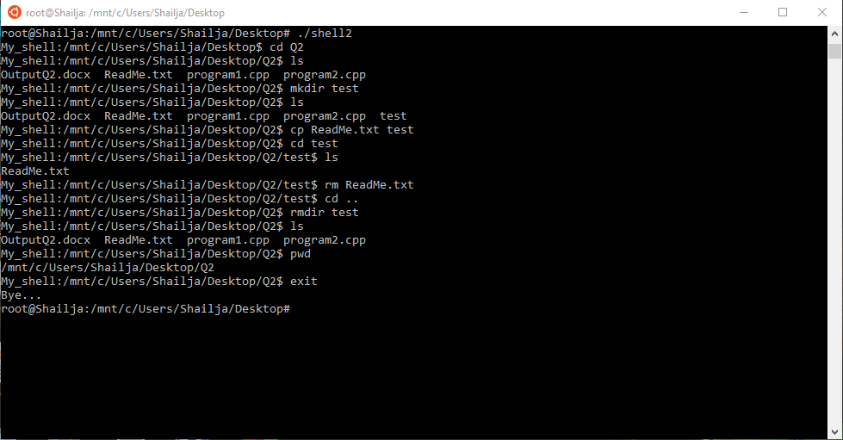

When executed in MacOS terminal, the output is as following:

The name of the shell is *My_Shell*

Commands **ls** and **pwd**

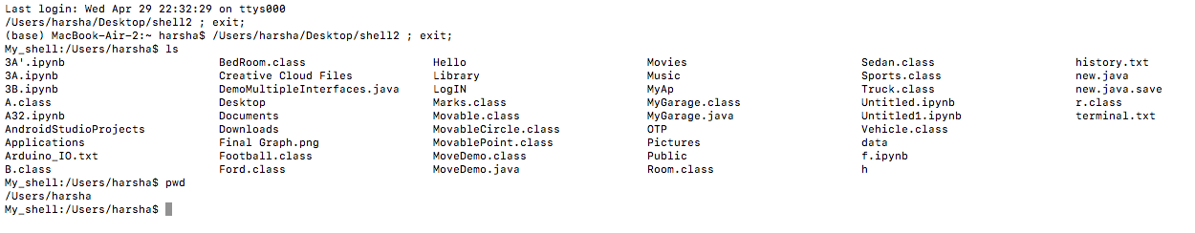

Command **mkdir** used along with pipe

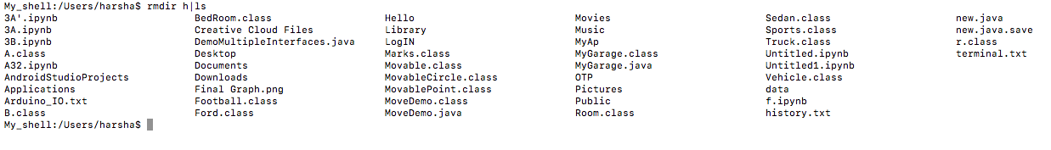

Commands **touch** and  **rm**:

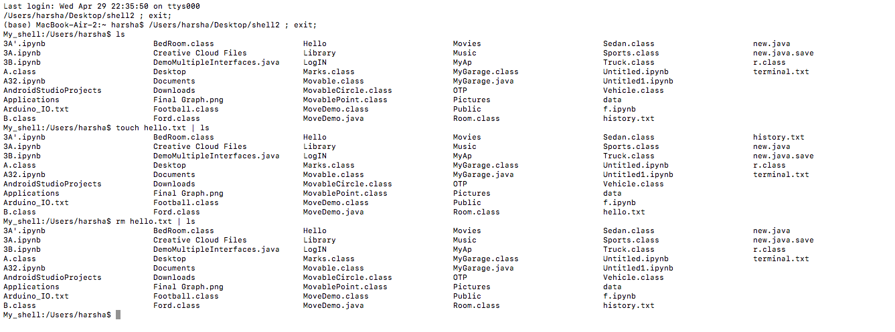

Command **cp:**

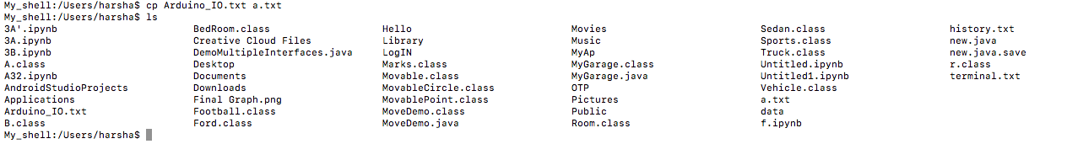

Unknown command message and **exit** command:

